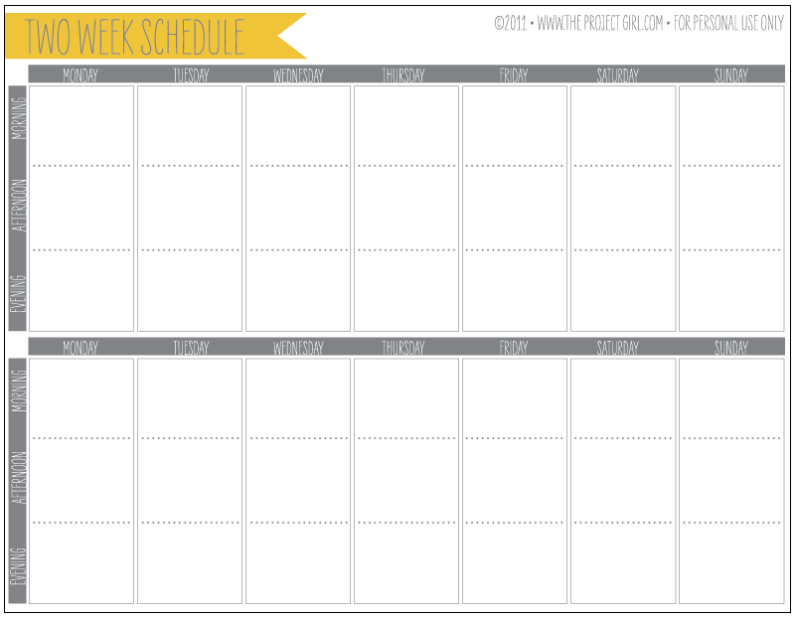

Directions: Pick a city anywhere in the world. Your job as a middle school meteorologist is to record the weather for your city. Log on to weather.com and write down the temperature and precipitation for the morning and night for all seven days of the week for two weeks. You can also use any weather app on a phone. If you do not have access to the internet or a phone, come see me so that I can help you.